**Task -4**

**Create a VM and encrypt the data disk attached to the VM by enabling Azure disk encryption and setting up Azure key vault also take a backup.**

**Step1: Create a Key vault**

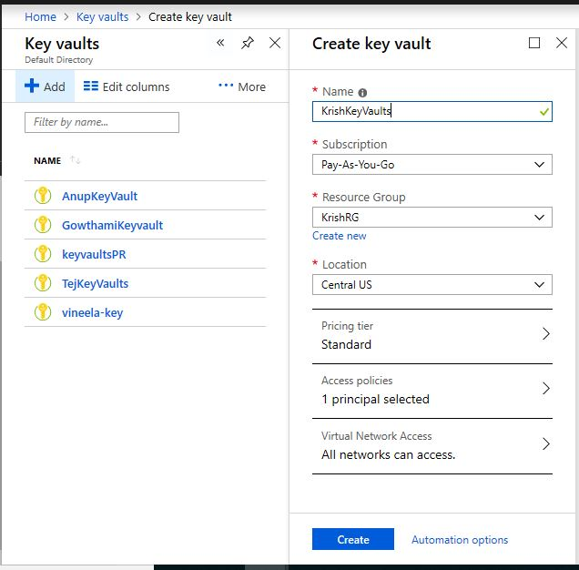

**Step2: Store key as client id**

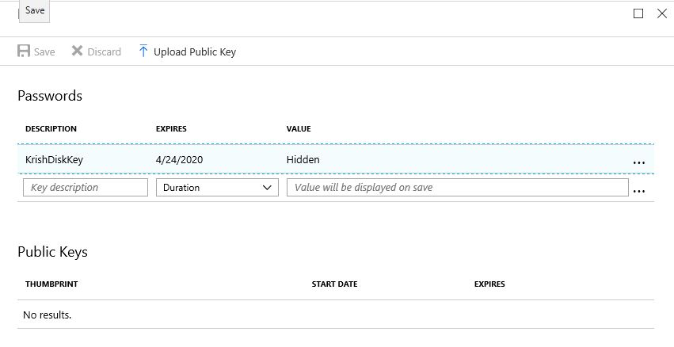

**Step3:Create an AppRegistry**

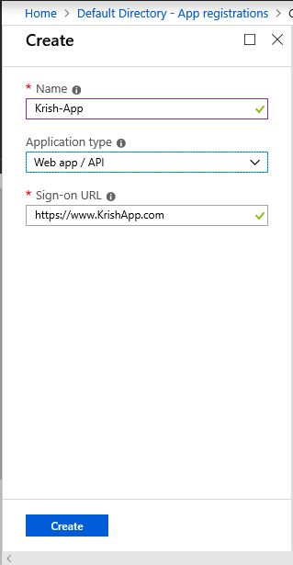

**Step4:Add Principal to the app**

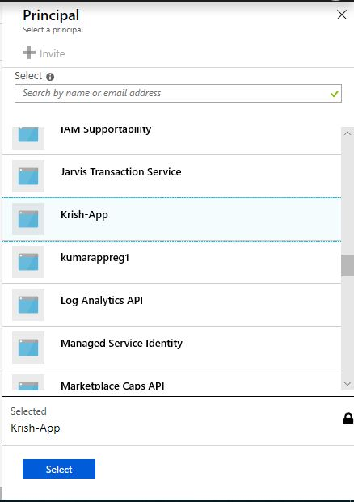

**Step5: Go to Access Policy and select permissions.**

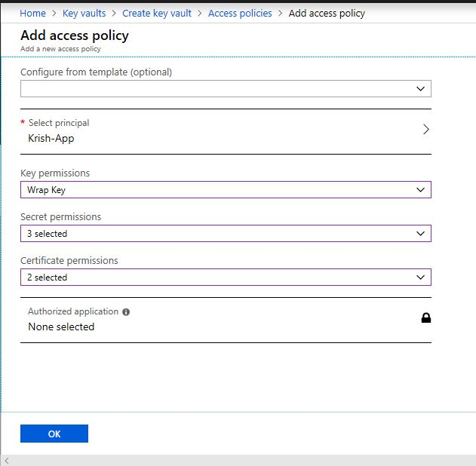

**Step6: 201-encrypt-running-windows and select**

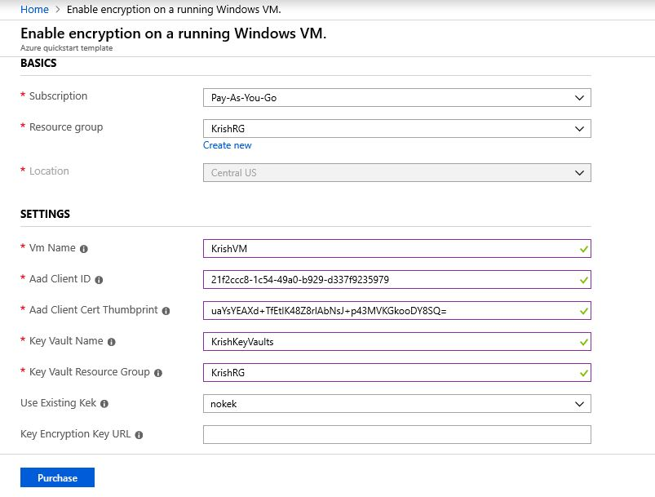

**Step7: Select Vm see that Encryption is enabled or not.**

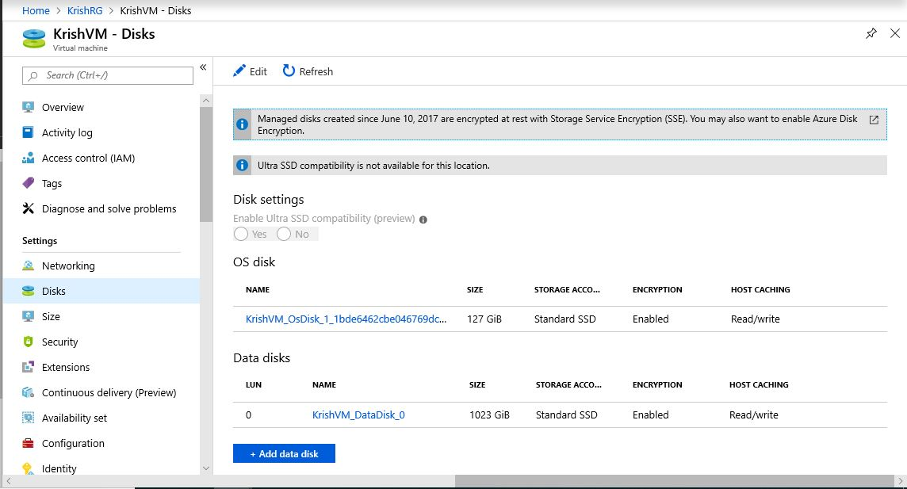

**Step-8:Create a recovery services Vault.**

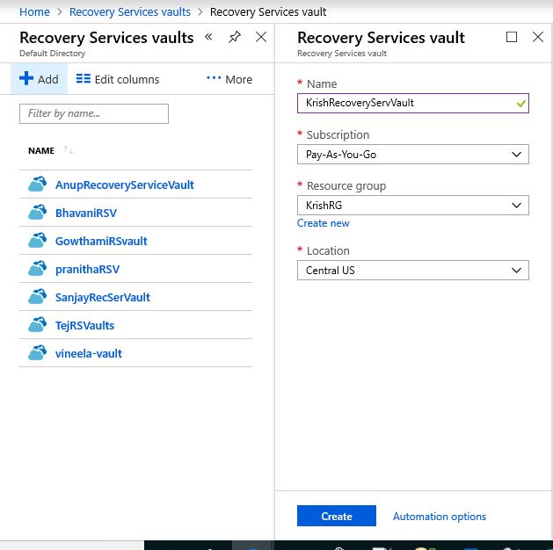

**Step9: Set up a backup goal.**

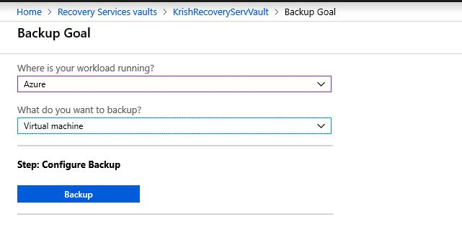

**Step10: Go to Backup goal and set Backup Policy.**

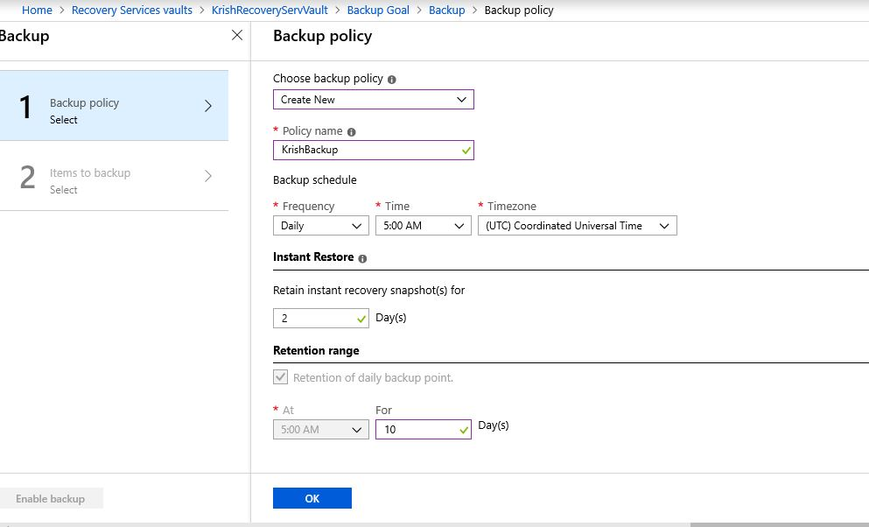

**Step11: Select VM for Backup**

